Focus on the big picture (Vision Statement)
How do we present what we do to students? Do they understand where their work is situated in the society?

- How do we benefit the society? With the support of the disciplines.
- How do we benefit the disciplines? With the support of the students.
- How do we benefit the students? With the support of the institution (UCF).
- How do we benefit the institution? With the support of the programs (departments).
- How do we benefit the programs? With the support of the faculty?
- How do we benefit the faculty? With the support of the society.

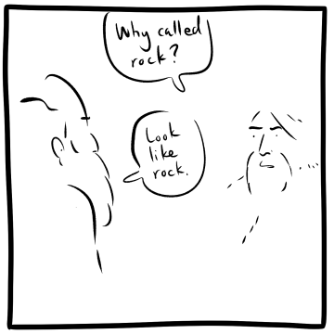

Section | Description
Assignment Title | Final Small Group Multimedia Presentation
Points/  Due Date | 100  Scaffolded throughout Semester
Assignment Learning Objectives | Synthesize concepts from class into unique creative project  Effectively interpret primary and secondary sources in research.  Promote collaboration and time management skills
Rationale for the objectives | Group work on presentation helps professionalize students through team building, time management, pitching ideas, accepting aid and giving feedback, etc  Provide students with opportunities to create worthy intellectual products
Authentic Learning Task Description and Sequencing | Group develops presentation  - Research potential venues for presentation  - Project proposal and consultation with faculty  - Complete outline and consultation with faculty  - Written portion developing presentation (paper, individual components workshopped by the group, memo or resume, conference proposal, etc) and should include images and can also be accompanied by music, video, objects, artifacts etc. For example a game design document might have a characters, story arc, mission level script, etc)  - Audio/visual component may include presentation and/or performance, curation
Tips for Successful Completion | Start early  Ensure you understand the instructions  Share your research with others in class  Visit the writing center  Rubrics (See attached examples) consultations with instructor/feedback from peers
Assessment  Criteria: checklist or rubric and schedule of formative feedback | Rubric – students have this from the first day of class (see attached examples)  Formative feedback – consultations with instructor initiated by student throughout the semester
Format requirements | Varies but may be audio/visual, in-person, powerpoint, or on paper (as a reflective final exam)

Sample rubrics:

